Open Source Intelligence (OSINT)
Investigation Report


Provided by ZCF Security

Table of Contents
Table of Contents 2
Confidentiality Statement 3
Disclaimer 3
Contact Information 3
Investigation Overview 4
Phases of an OSINT investigation 4
Challenge #1: Snoop’s Hoodie 5
Summary 5
Technical Evidence 1.1 – Instagram Reel 6
Technical Evidence 1.2 – Retired Uniform Numbers 7
Technical Evidence 1.3 – Postal Code 8
Challenge #2: 90’s Cartoon Action Figure 9
Summary 9
Technical Evidence 2.1 – Film Artwork 11
Technical Evidence 2.2 – Famous Movie Actor 12
Technical Evidence 2.3 – Co Star & Award 13
Challenge #3: Park Identification 16
Summary 16
Technical Evidence 3.1 – National Park 18
Technical Evidence 3.2 – Expeditionist & Museum 19
Technical Evidence 3.3 – Festive Hat 21

Confidentiality Statement
This document is the exclusive property of Epstein Foundation and ZCF Security. This document contains proprietary and confidential information. Duplication, redistribution, or use, in whole or in part, in any form, requires consent of both Epstein Foundation and ZCF Security. Epstein Foundation may share this document with auditors under non-disclosure agreements to demonstrate compliance.

Disclaimer
This Open-Source Intelligence (OSINT) Investigation report has been compiled by ZCF Security based on information available in the public domain as of May 1st 2025. While efforts have been made to ensure the accuracy of the information, it is subject to change. An OSINT investigation is considered a snapshot in time. The findings and recommendations reflect the information gathered during the assessment and not any changes or modifications made outside of that period.

Contact Information
Epstein Foundation
Name | Title | Contact Information
Renne Bright | Chief Information Security Officer | rbright@epsteinfoundation.com

ZCF Security
Name | Title | Contact Information
Hiro Newf | Lead OSINT Investigator | hnewf@zcf-security.com

Investigation Overview
From May 1st 2025 to May 2nd 2025, the OSINT Investigator from ZCF Security conducted an Open-Source Intelligence (OSINT) investigation. The findings presented in this overview are derived from open-source data and do not involve any unauthorized access to private or confidential information. An OSINT risk assessment emulates the role of a threat actor employing methods like those utilized by malicious entities to gather information. Through data collection and analysis, an investigator will search open sources to identify potential risks, culminating in an assessment and profiling of discovered information.

This OSINT investigation aims to provide a realistic representation of the information landscape from a threat actor's perspective, enabling a proactive approach to strengthening organizational resilience.

Phases of an OSINT investigation


Challenge #1: Snoop’s Hoodie

Summary

  - Objective:
On Jan 15, 2024 Snoop Dogg posted a video on social media where he’s wearing a yellow hoodie from what US sports team?

This team has "officially retired" three uniform numbers. What are they?

We can make a postal code when we string those uniform numbers from from greatest to least. Where is that postal code?

  - Key Findings:
ZCF Security located an Instagram reel video, posted on Jan 15th 2024, in which Snoop Dogg was wearing a yellow hoodie from the Steelers US baseball team.

Upon further research it was discovered on the WTAE website that the three retired uniform numbers from the Steelers are 70, 75, & 32.

When put together in order from greatest to least we get the postal code of 757032, which is located in Bangriposi, India.

Technical Evidence 1.1 – Instagram Reel

Overview: | ZCF Security utilized advanced search features of popular social media platforms like X (formally Twitter) and Instagram in order to see any posts from the subject “Snoop Dogg” during the 15th of January 2024.  Upon performing this research we located an Instagram Reel in which Snoop Dogg was wearing a yellow hoodie for the Pittsburgh baseball team “Steelers”.
Link(s): | https://www.instagram.com/reel/C2H-y2kMv-p/?l=en
Notes: | N/A

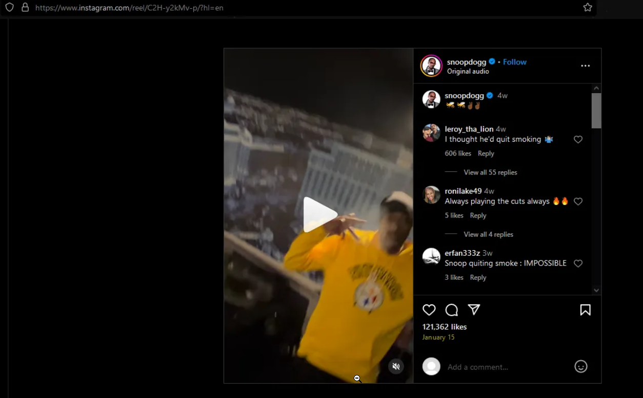

Figure 1: Snoop Dogg’s Instagram reel from January 15th, 2024 in which we can clearly see his Steeler’s hoodie

Technical Evidence 1.2 – Retired Uniform Numbers

Overview: | ZCF Security performed a search on the Steelers baseball team in order to locate the three retired uniform numbers. This information was found on the WTAE website in a post from August 19th, 2023. Within this article it was learned that the three retired numbers are 70, 75 & 32.
Link(s): | https://www.wtae.com/article/steelers-franco-harris-retired-jersey-display/44857959
Notes: | Near the beginning of the article by WTAE can we see the three retired numbers listed, this information can also be confirmed from many other sources.

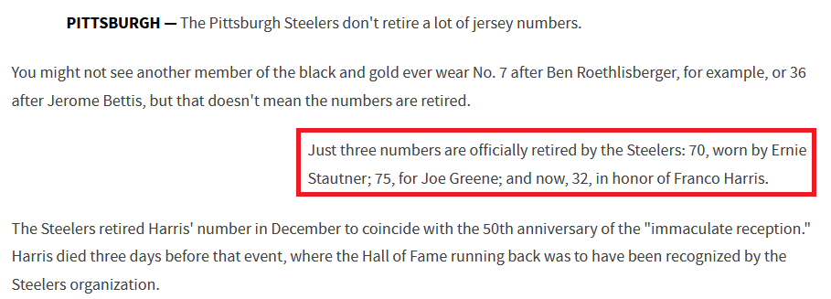

Figure 1: The WTAE article in which the three retired uniform numbers are mentioned

Technical Evidence 1.3 – Postal Code

Overview: | With the uniform numbers of 70, 75, & 32 in hand ZCF was easily able to put them in the desired order (greatest to least) in order to get the postal code of 757032.  This code was then typed into google maps where we learned that the code is located in Bangriposi, India.
Link(s): | https://www.google.com/maps/place/Bangriposi,+Odisha+757032,+India/@22.1103796,86.5214114,12z/data=!4m6!3m5!1s0x3a1dc0957531c18d:0x8e65629f89b637fe!8m2!3d22.1429092!4d86.5703554!16s%2Fg%2F1hhwfvx5l?entry=ttu&g_ep=EgoyMDI1MDQyOC4wIKXMDSoASAFQAw%3D%3D
Notes: | N/A

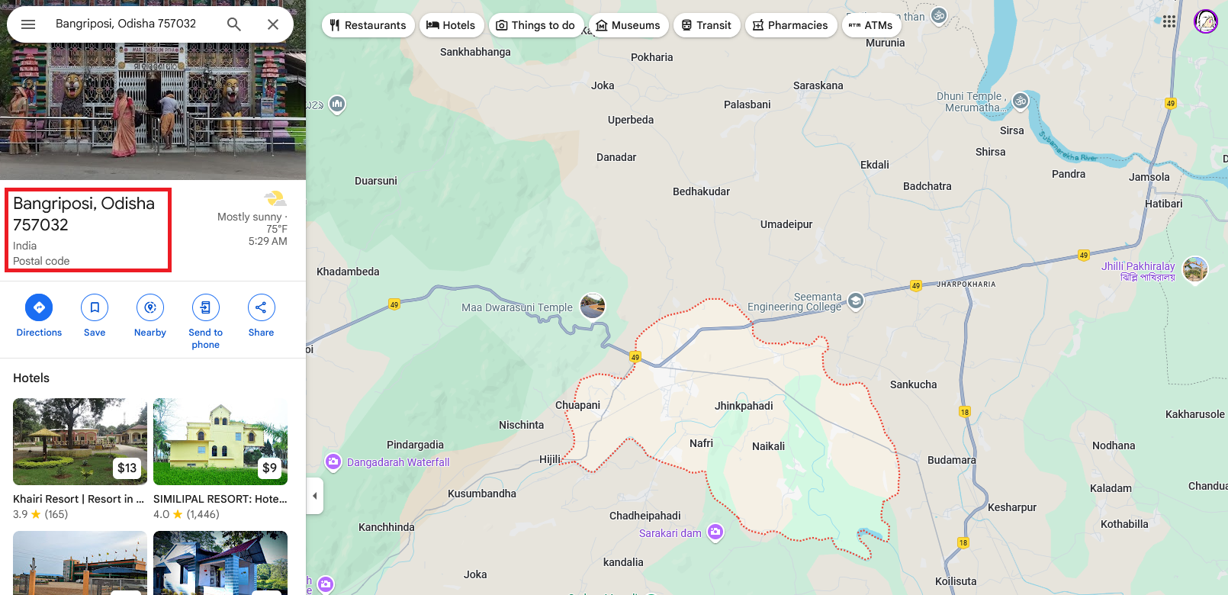

Figure 1: Google Maps search result for the postal code of 757032

Challenge #2: 90’s Cartoon Action Figure

Summary

  - Objective:
This art is inspired by a 90s cartoon. Aside from telling us what show this is inspired by, also identify the now famous movie actor who showed off their action figures in 1995.

From an Entertainment Tonight vault video, we again find our toy fair actor being interviewed with another up and coming actor around the 2:00 mark. These two would end up playing together in another movie just 5 years later.

What is it and what is the award this movie would win?

  - Provided Artwork:
  - 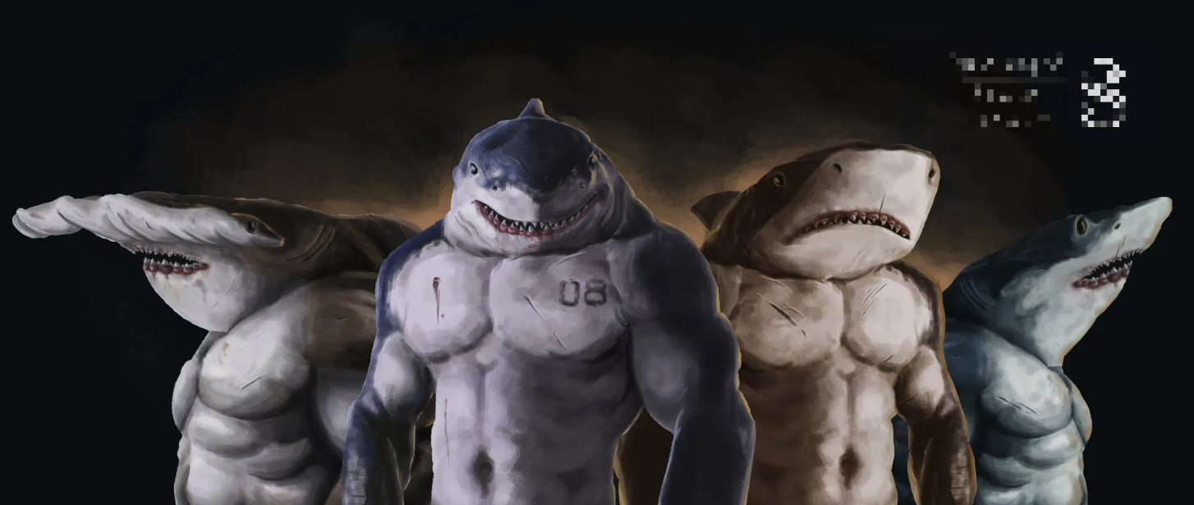
  - Key Findings:
Reverse image searching was performed on the artwork which revealed that it was fan art of a show called Street Sharks. Further research confirmed that this show was indeed from the 90’s.

Some Google Fu (advanced Google searches) were done in order to find the famous movie actor that showed off the Street Sharks action figures. This revealed that Vin Diesel, long before he became famous, advertised for the Street Sharks products in a commercial.

Next ZCF Security found the Entertainment Tonight vault video, which was done with another Google search and heading to the Videos tab until a video from the Entertainment Tonight youtube channel, that was posted on April 4th 2020, was located with Vin Diesel on the thumbnail. Upon watching this video at the 2 minute mark we see Vin Diesel alongside fellow actor, Giovanni Ribisi.

With our two award winning actors known we could search for both of their names together which led us to a movie titled Boiler Room. On the wikipedia page for this film, under the Awards and Nominations section, it was noted that the film was nominated for many awards, but won only one, the “Jury Special Prize” at the Deauville American Film Festival.

Technical Evidence 2.1 – Film Artwork
Overview: | Reverse image searches were performed in order to locate the film associated with the provided artwork. ZCF learned via a Pinterest post found through the image search, that the artwork was fan art for a 90’s cartoon “Street Sharks”
Link(s): | https://www.pinterest.com/pin/713398397197378123/
Notes: | The circled post in figure 1 is the one that provided us with the show name as displayed in figure 2.

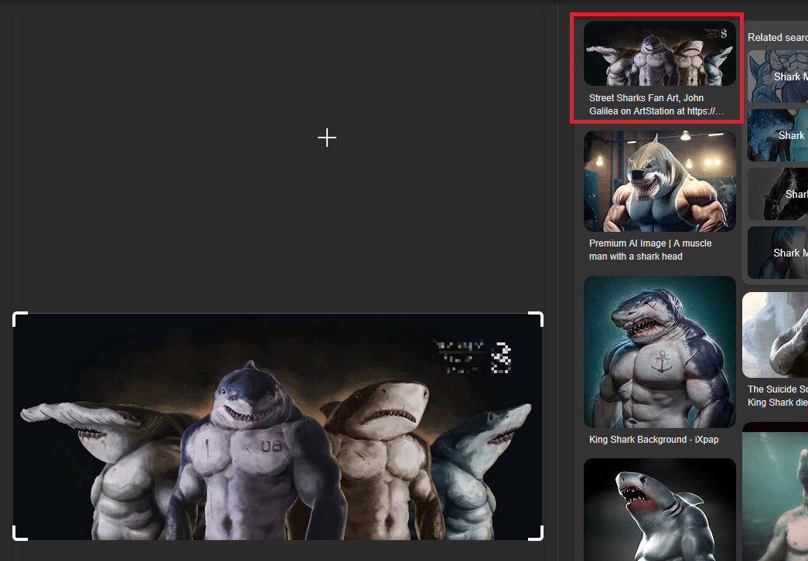

Figure 1: Initial reverse image search which led us to the Pinterest post

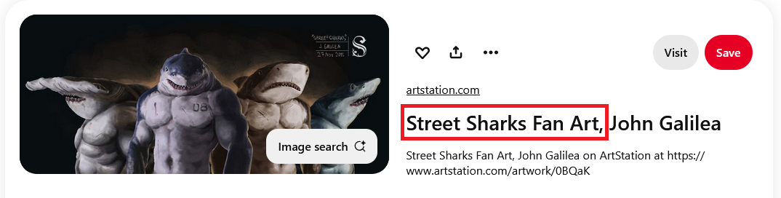

Figure 2: Pinterest post in which the cartoon name was mentioned

Technical Evidence 2.2 – Famous Movie Actor

Overview: | A search for “Street Sharks action figures 1995” was performed, scrolling down to the “People also ask” section of Google showed us the question “Was Vin Diesel in Street Sharks?”. Well isn’t that interesting, was he Google? Upon looking at the answer to the question it was revealed that Vin Diesel was indeed the famous movie actor that advertised for the cartoon’s figures in the past.
Link(s): | https://www.fatherly.com/news/vin-diesel-street-sharks-video
Notes: | N/A

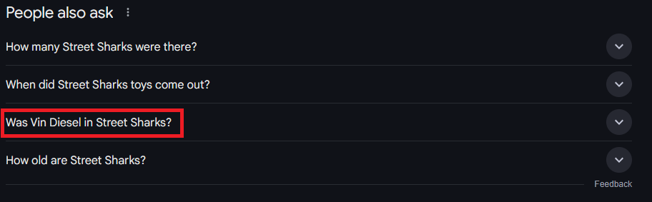

Figure 1: Results from the initial “Street Sharks action figures 1995” search

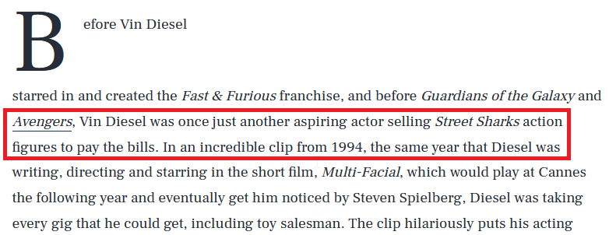

Figure 2: Snippet from a fatherly article about Vin Diesel and Street Sharks

Technical Evidence 2.3 – Co Star & Award

Overview: | ZCF Security searched for “Vin Diesel Street Sharks video with another actor 5 years before co-starring together” and switched to the videos tab to locate a video from the Youtube channel "Entertainment Tonight”, that was posted April 4th 2020, with Vin Diesel clearly seen in its thumbnail.  Upon finding the video it was watched at roughly the 2 minute mark to see Vin Diesel sitting alongside fellow actor Giovanni Ribisi. Placing both of their names together into the search for “Giovanni Ribisi & Vin Diesel” a movie called “Boiler Room” popped up.  The Wikipedia page for this film, under the awards and nominations section, held the information about the award won. While it seemed that the film was nominated many times, the Jury Special Prize at the Deauville American Film Festival was the only award achieved.
Link(s): | https://www.youtube.com/watch?v=0yCZwC4eDzs  https://en.wikipedia.org/wiki/Boiler_Room_(film)
Notes: | N/A

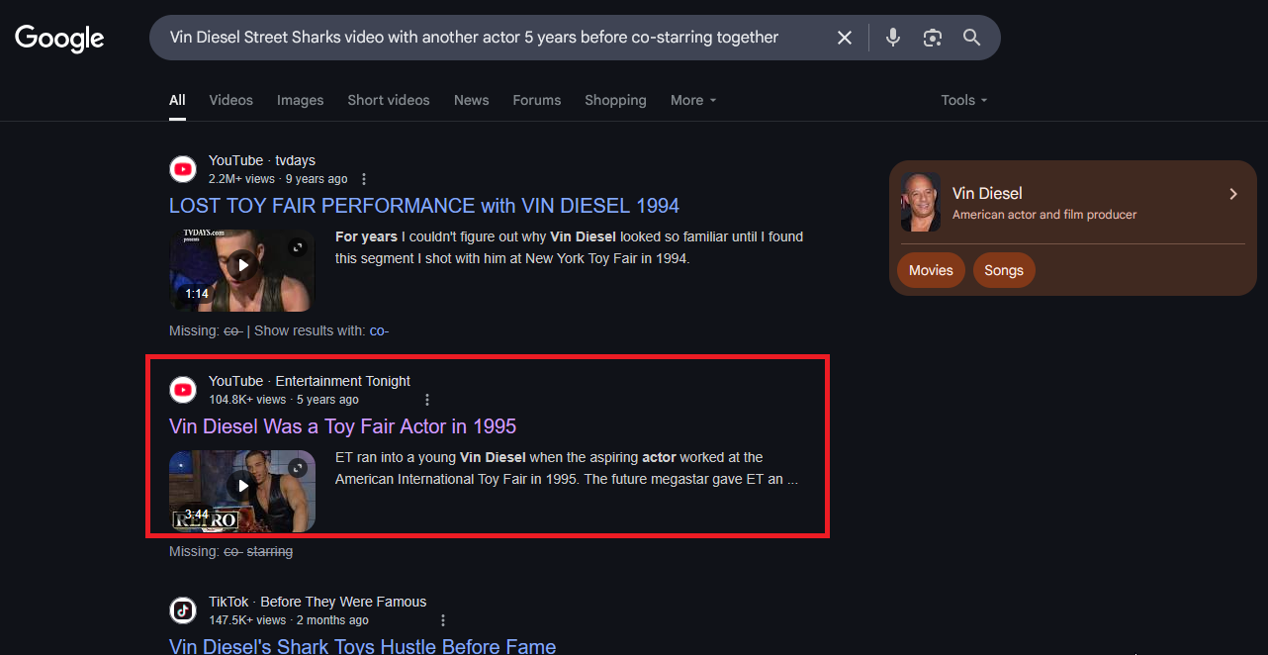

Figure 1: The search in which the interview with a fellow actor video was found
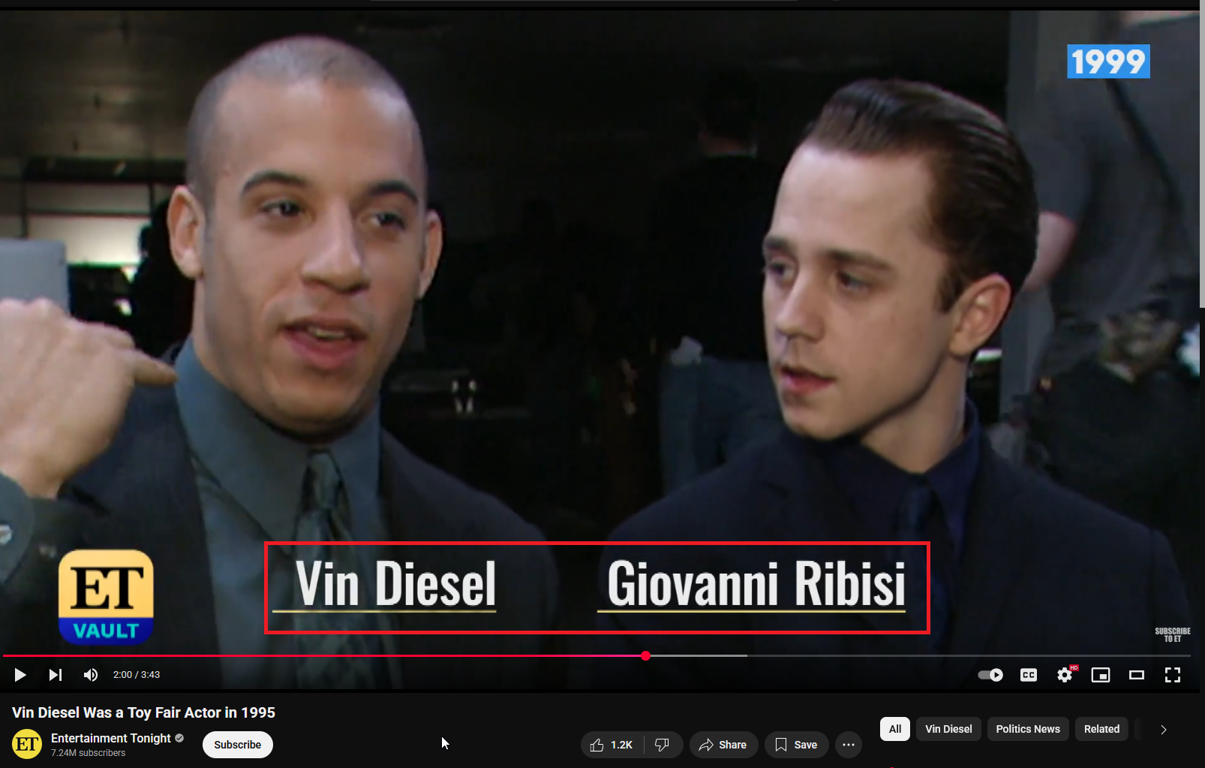

Figure 2: Vin Diesel alongside Giovanni Ribisi in an Entertainment Tonight Youtube video

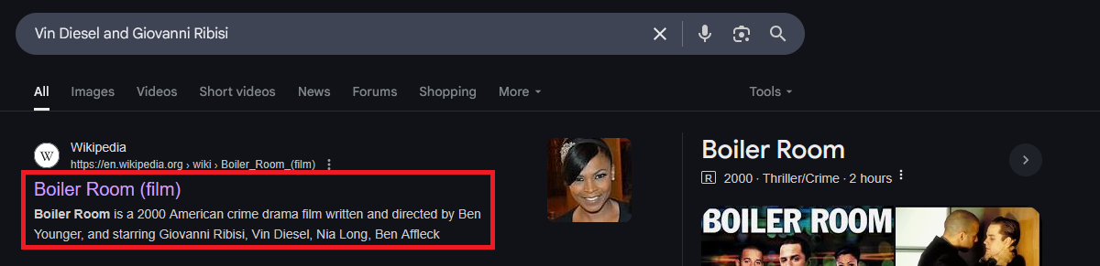

Figure 3: Google search which resulted in the Boiler Room movie, starring both actors being found

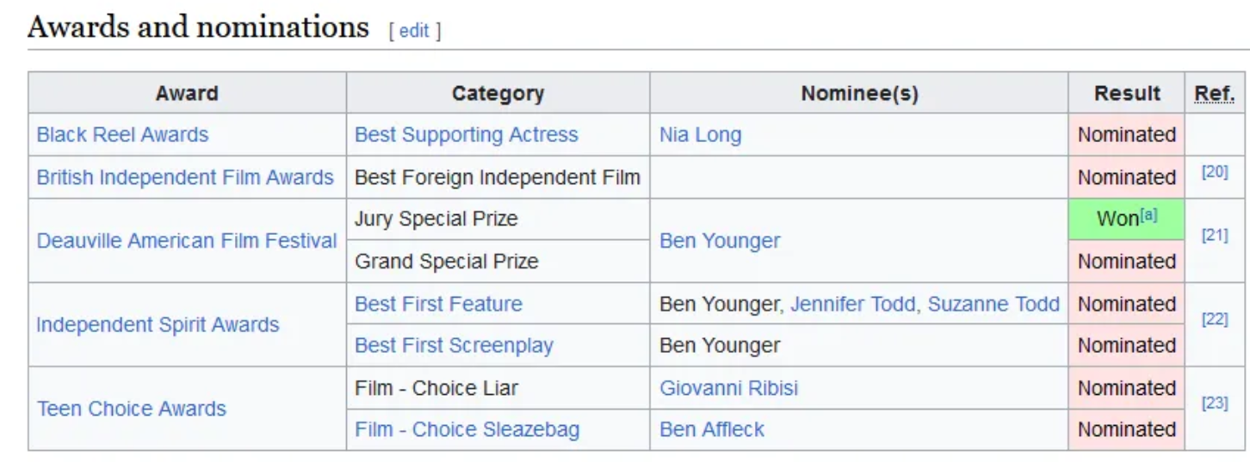

Figure 4: Awards section of the wikipedia page for the Boiler Room film showcases the won award

Challenge #3: Park Identification

Summary

  - Objective:
This park is named after an interesting geological finding here, one of the largest collections in the world. These curiosities would inspire many paleontologists to do research here, one of the first being an interesting character. Who was the paleontologist that first led a fossil expedition in the park and what museum did they fund and establish in 1908?
Not many can say they’ve been to this museum as it is closed to the public. Rumor has it, however, that a resident fossil there adorns a festive hat sometimes. Find the picture, I promise at least one exists out there.
To succeed at this challenge, you’ll need to correctly answer the following questions:
What national park is this?
Who first led a fossil expedition in this park and what is the name of the museum established?
What fossil wears a festive hat at the museum identified above?

  - Park Photograph:
  - 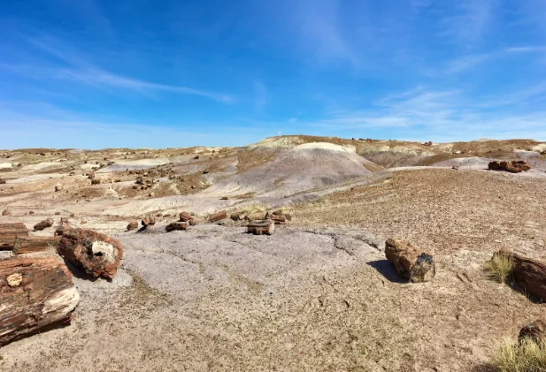
  - Key Findings:
ZCF Security performed a search on the provided image of the park which revealed many similar photos, some even of nearly the exact same location and angle, like the one found on the stock image site “Dreamstime”. This site gave us the name of the park as “Petrified Forest National Park” located in Arizona.

Next ZCF searched the name of the park along with the words “Fossil expedition” and found the National Park Service’s website which listed all of the major scientists and researchers involved with the park in the past. The second name mentioned here “Annie Montague Alexander” seemed to be who we were looking for as upon reading her wikipedia page she did indeed found a museum in 1908 by the name of “Museum of Vertebrate Zoology” (MVZ).

Finally the museum was investigated in order to locate the fossil wearing the festive hat. A Reddit post by the user “sh221bbkr” shows a T-rex with a small santa hat on its head. Scrolling down through the comments this same user confirms that this was taken from the Museum of Vertebrate Zoology.

Technical Evidence 3.1 – National Park

Overview: | ZCF Security performed a reverse search on the provided image of the park which revealed many similar photos on various platforms, some even of nearly the exact same location and angle, like the one found on the stock image site “Dreamstime”.  This site, along with just Google’s best guess at the location, gave us the “Petrified Forest National Park” located in Arizona, US.
Link(s): | https://www.dreamstime.com/petrified-forest-near-holbrook-arizona-petrified-forest-near-holbrook-arizona-usa-image99826460
Notes: | N/A

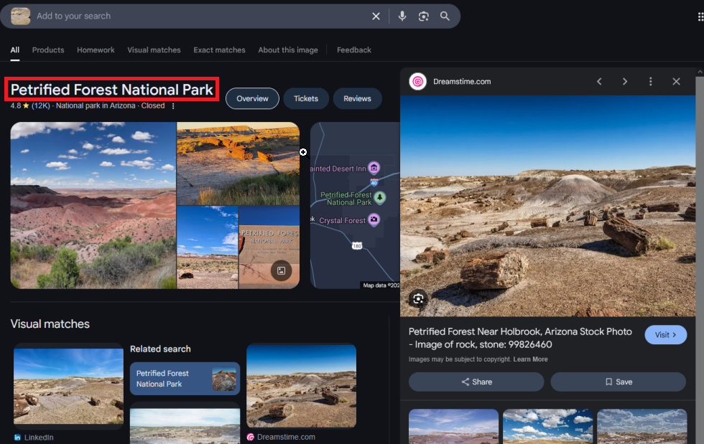

Figure 1: Google geolocating the national park photo that was provided

Technical Evidence 3.2 – Expeditionist & Museum

Overview: | A search for “Petrified Forest National Park fossil expedition” was performed and that led ZCF to the National Park Service’s website, which listed all of the major scientists and researchers involved with the park in the past.  The second name mentioned here, Annie Montague Alexander, seemed to be who we were looking for as upon reading her wikipedia page she did indeed found a museum in 1908 by the name of “Museum of Vertebrate Zoology” (MVZ).
Link(s): | https://www.nps.gov/pefo/learn/historyculture/scientistsresearchers.htm  https://en.wikipedia.org/wiki/Annie_Montague_Alexander
Notes: | N/A

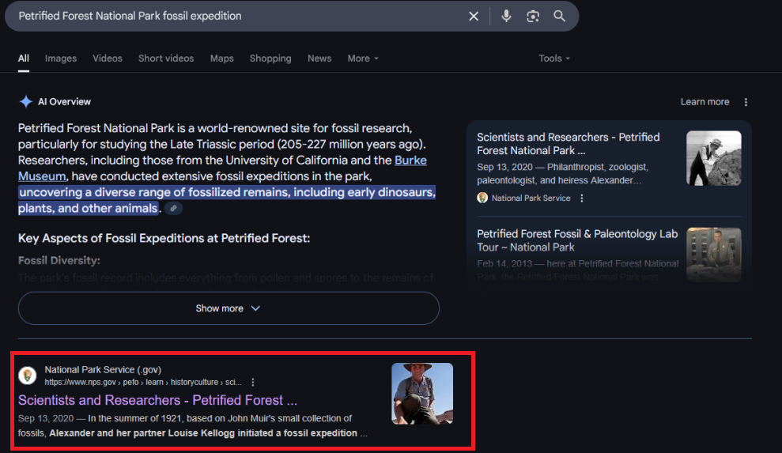

Figure 1: Search for the fossil expedition which led to the nps website

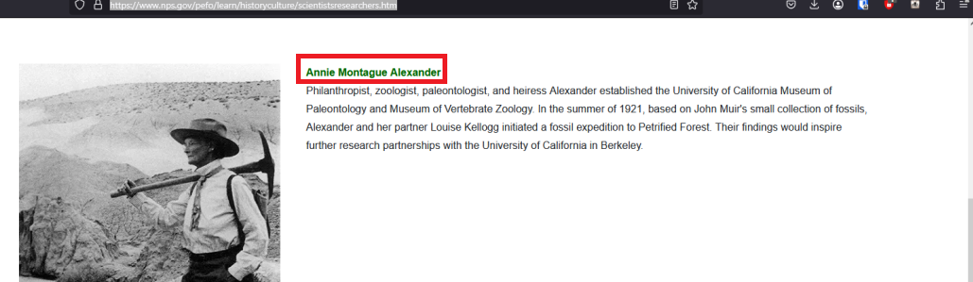

Figure 2: Annie being mentioned on the nps website article about the national park

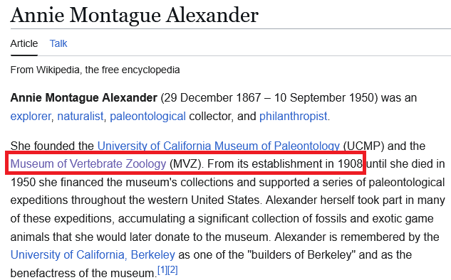

Figure 3: Annie’s wikipedia page which mentions the museum she founded in 1908

Technical Evidence 3.3 – Festive Hat

Overview: | The museum was investigated in order to locate the fossil wearing the festive hat. Within a Reddit post by the user “sh221bbkr” there is a photograph showing a T-rex with a small santa hat on its head. Scrolling down through the comments of this post, this same user confirms that this photo was taken from the Museum of Vertebrate Zoology.
Link(s): | https://www.reddit.com/r/mildlyinteresting/comments/a5wdpn/this_hat_they_put_onto_the_trex_at_my_university/
Notes: | N/A

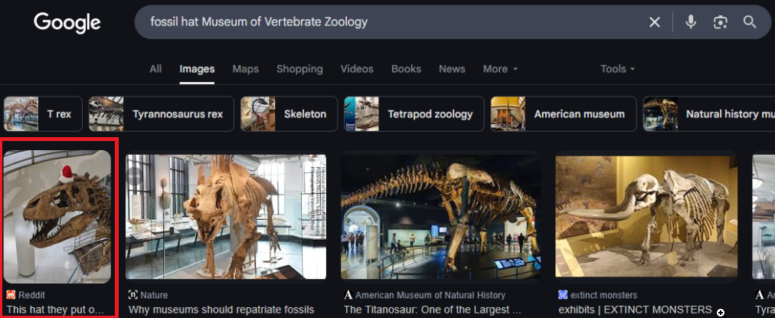

Figure 1: Google search for the festive hat wearer

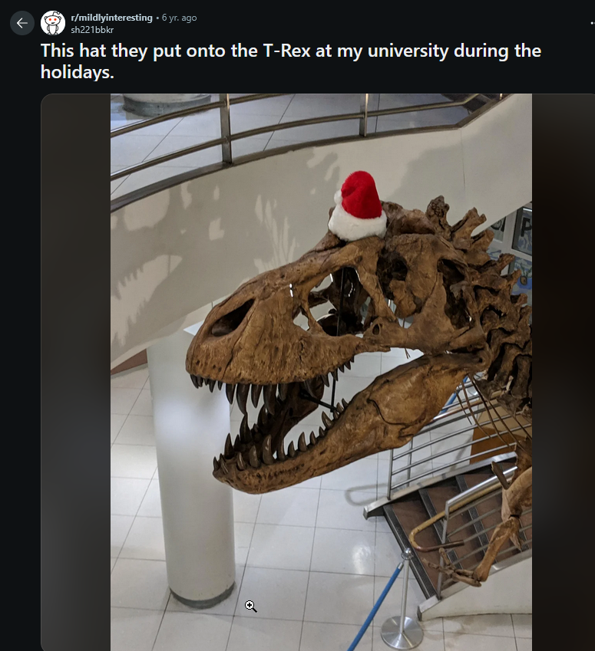

Figure 2: Reddit post with the T-rex wearing the santa hat

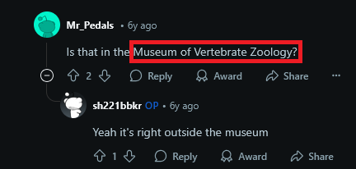

Figure 3: The original poster of the image confirming its location

